Sheikh Abdullah inaugurates Musafir.com
April 23, 2009
Sharjah, United Arab Emirates
HE Sheikh Abdullah bin Mohammed Al Thani, chairman of the Sharjah Department of Civil Aviation today inaugurated the UAE’s first travel website which combines flight and hotel searches in a single click – Musafir.com. The event held at the Sharjah Golf and Shooting Club was attended by leaders of the local business community and representatives of the travel industry.
Musafir.com, which already offers flights to over 3,000 destinations on all leading airlines, will launch its hotel booking service to travelers in the UAE on May 1, 2009 with rooms in over 23,000 hotels around the world to choose from.
“The freedom to combine your own flight and hotel presents a significant cost saving opportunity to travelers this summer”, said the company’s founders, citing the availability of connecting flights and hotels in nearby suburbs for a number of cities on Musafir.com.
Online travel bookings are expected to account for over 30 percent of the UAE’s outbound leisure travel market by 2012, with e-ticketing and the zero-commission model being credited in particular. Musafir.com plans to introduce a number of new services in 2009, including low-cost flights, for which it announced the signing of a letter of intent in the presence of Air Arabia CEO Adel Ali at the event.
###

About the company | Musafir (pronounced moo-saa-fir) means “traveler” in several regional languages, including Arabic, Farsi, Hindi and Urdu. The website offers flights to over 3,000 destinations on all leading airlines, rooms in over 23,000 hotels around the world and both at in a single click.  Musafir.com is incorporated under Universal Tourism and was founded in August 2007 by Sheikh Mohammed bin Abdullah Al Thani, Sachin Gadoya and Albert Dias. The company is investing AED 3 million in the development of a proprietary trip planning solution over the next two years to make planning holidays from the UAE easier than anywhere else in the region today.
Contact us  for further information | Musafir.com  Phone : +971 6 557 2000  Email : pr@musafir.com
Media to complement  this article | 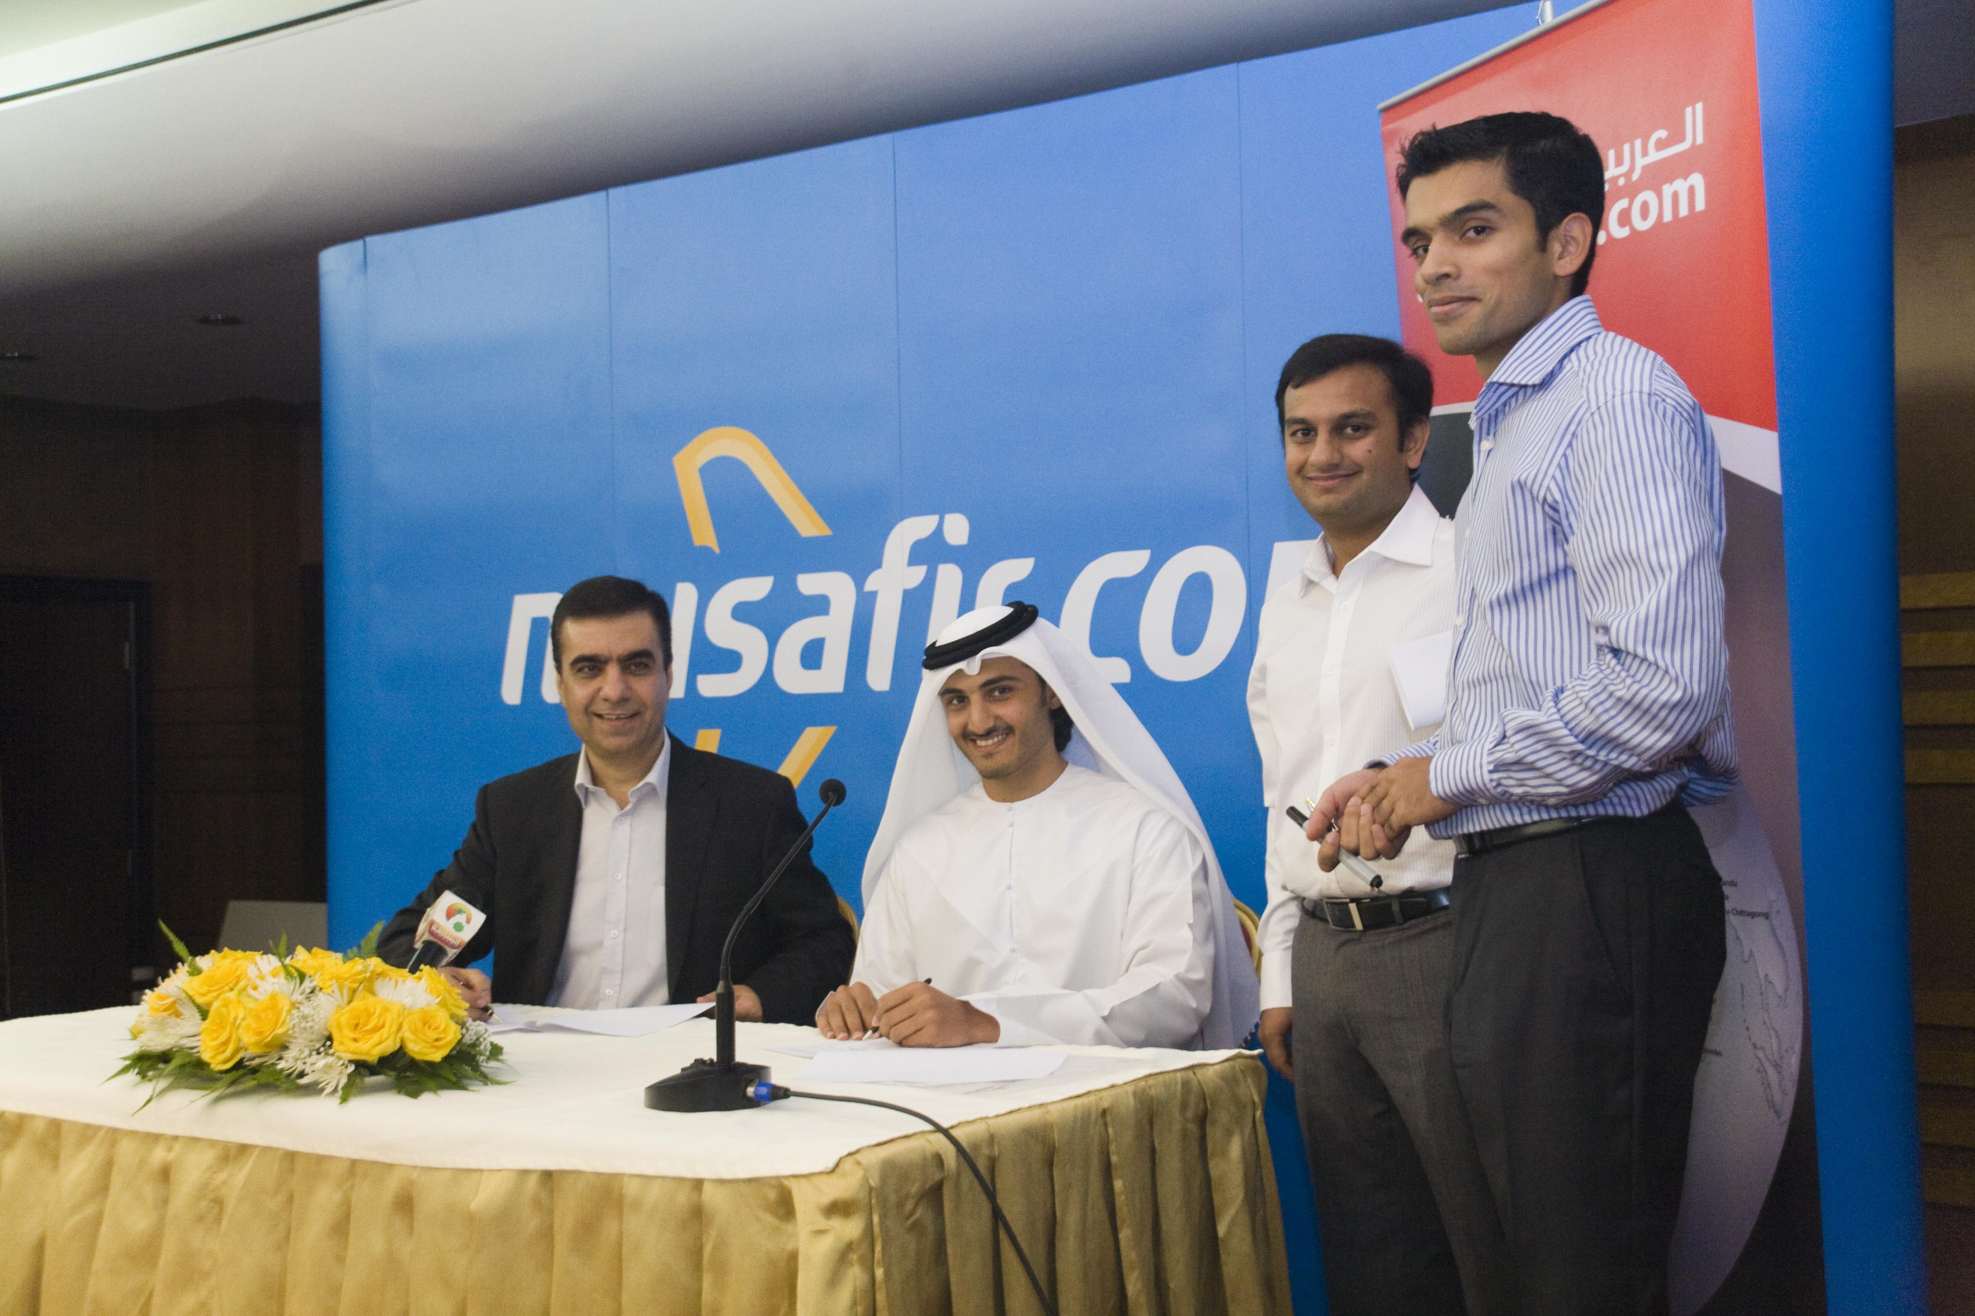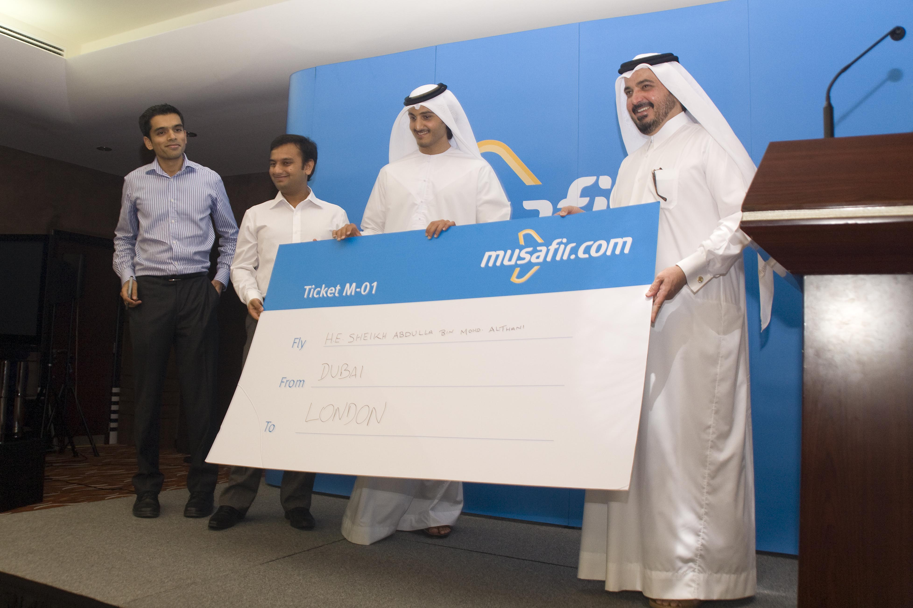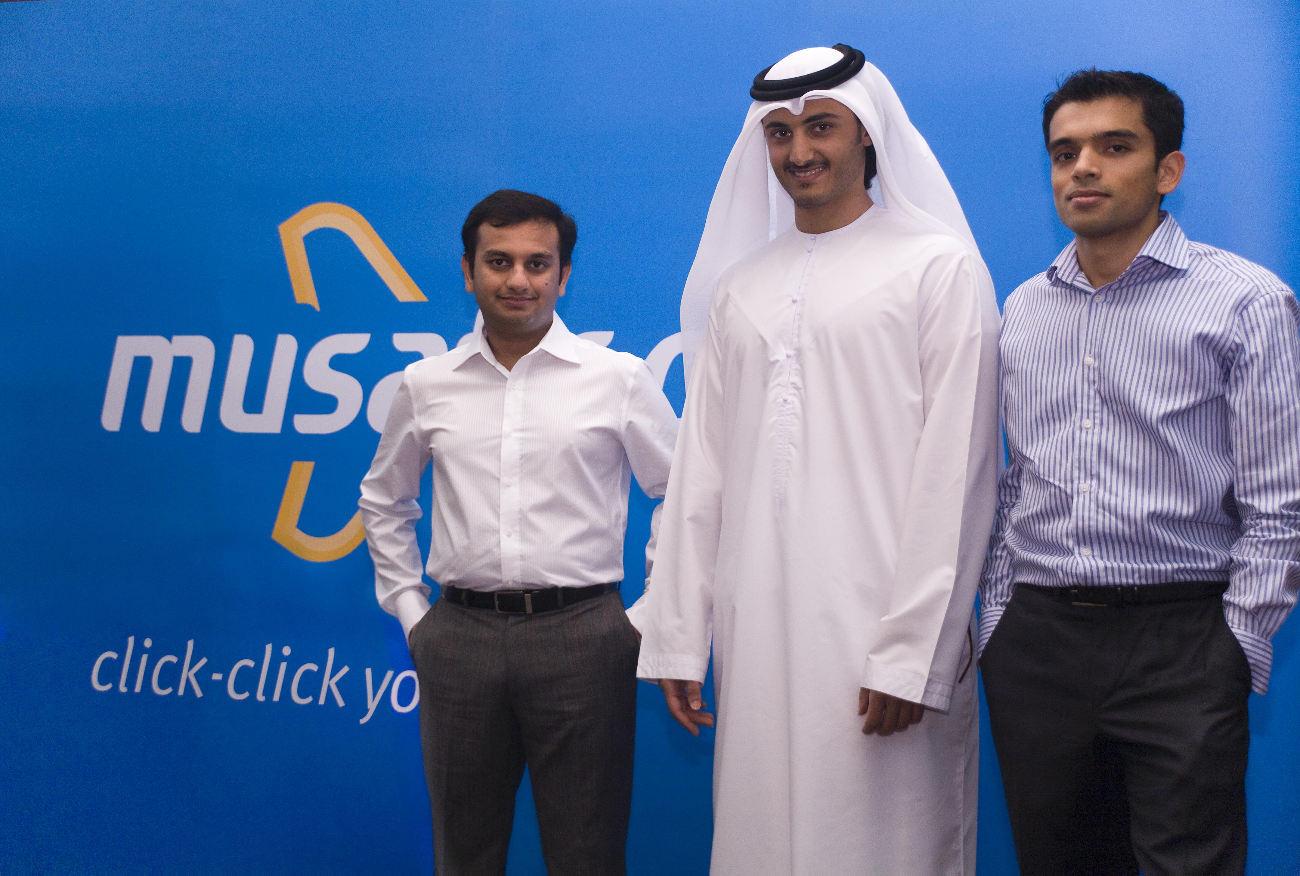  Download the originals from http://www.musafir.com/media.aspx

